# Bug 1 Hypothesis:

The problem with bug one, is that the player’s balance is not being correctly compounded with their winnings and their bet after they win a round.

The problem lies in line 57 of player.java: balance = balance + winnings;)

And line 50 of game.java: player.receiveWinnings(winnings);

### Evidence within Debugging:

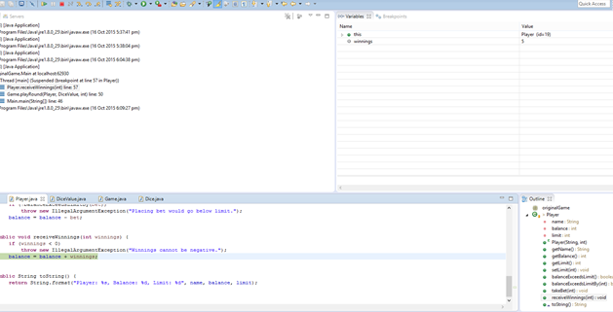

### Evidence in Output:

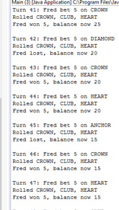

Balance is not increasing correctly

### Sane/Infected:

Prior to the function “receiveWinnings,” the value parsed to this function was deemed sane, however after the value was parsed through this function, it caused the balanced to become infected with an inaccurate value.

# Bug 1 Resolution

The bug can easily be resolved by changing the following lines of code:

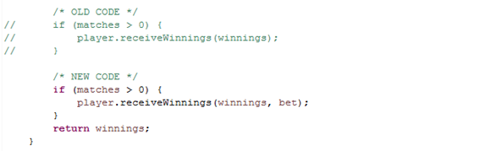

Figure 1 In Game.java lines 54 to 58

And

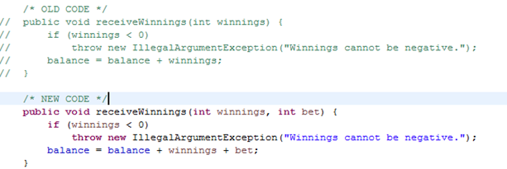

Figure 2 In player.java lines 62 to 66

## Evidence of Resolved Bug in Automated Testing (TestBugOne.java):

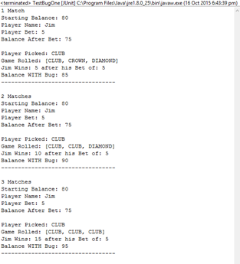

# Resolution of Bug: UAT

| **Test Name** | | Balance Bug 1 |
| --- | --- | --- |
| **Use Case Tested:** | | Deliver payout |
| **Test Description:** | | Calculate Payment and Deliver payout:   * User should be able to observe their new balance is correctly updated. |
| **Pre-conditions** | | * Console Exists * Game Exists * 3 Dice Exist * Player Exists Player has declared their bet Player’s Balance exceeds their bet declaration * totalWins, totalLosses, winCount, loseCount and turn are initialized to Zero |
| **Post-conditions** | | * Correct Results being displayed within the IDE |
| **Notes:** | **We are testing to see if the bug has been correctly fixed after tracing and resolution.** | |
| **Result (Pass/Fail/Warning/Incomplete)** | **Pass – Bug 1 Resolved** | |

|  | **TEST STEP** | **EXPECTED TEST RESULTS** | P | F |
| --- | --- | --- | --- | --- |
|  | User runs Main.java | Program executes and results can be seen in console | X |  |
|  | User can observe their balance is being correctly calculated at the end of each round, whether they’re winning or loses. | The player’s balance is correctly calculated and updated and entirely relational to the amount of dice they matched with their pick. | X |  |